Housing Trends
Housing is an important need because it intersects with many other aspects of daily life needed for success. A home is the primary place for family life, relaxation from work or school, and an asset that builds financial wealth and stability. When families lack stable housing, the entire family suffers. Access to safe and affordable housing continues to be a number one need in Linn County, based on United Way’s 2-1-1 information and referral. Housing Cost Burden (HCB) is high in Linn County especially for renters.
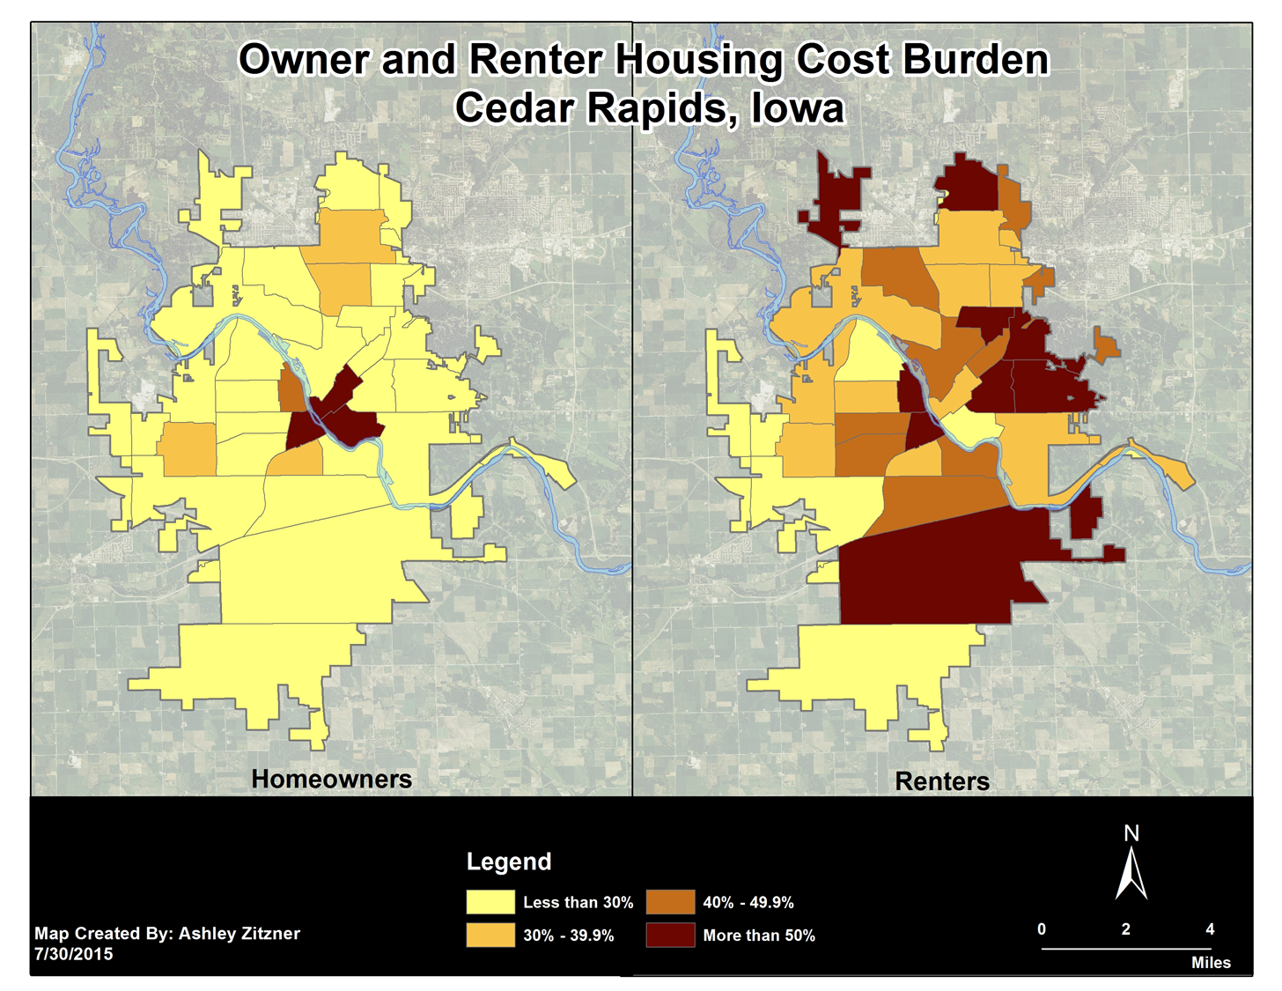
The data shows (in the line graph above and the map below) that renters are most likely to be housing cost burdened.

When we look back nearly 30 years, housing cost burden has always been high for renters but has increased at a rate of 30% since 1990. Since 2000, housing cost burden has steadily increased for renters. Alternatively, when we look at affordability for homeowners, there was a peak of 20% in 2010 as a result of the recession, but have more recently seen declines in housing cost burden.
Housing matters. When quality affordable housing is not accessible, families double up or find poorer quality housing that is more affordable. Worse yet, they can wind up homeless or in temporary shelter. Providing housing and resources for unstable, near-homeless, or homeless families is important. Strategies that provide safe, stable, long-term, and supportive housing solutions for families are critical to future success.

The Benefits Cliff
The “benefits cliff” describes what happens when public benefits programs “drop-off” as families earn more money. This leads to an abrupt loss of public benefits that make low-income families worse off. This is why we often see families reject wages or slightly higher income positions. The cliff is depicted in the image below.
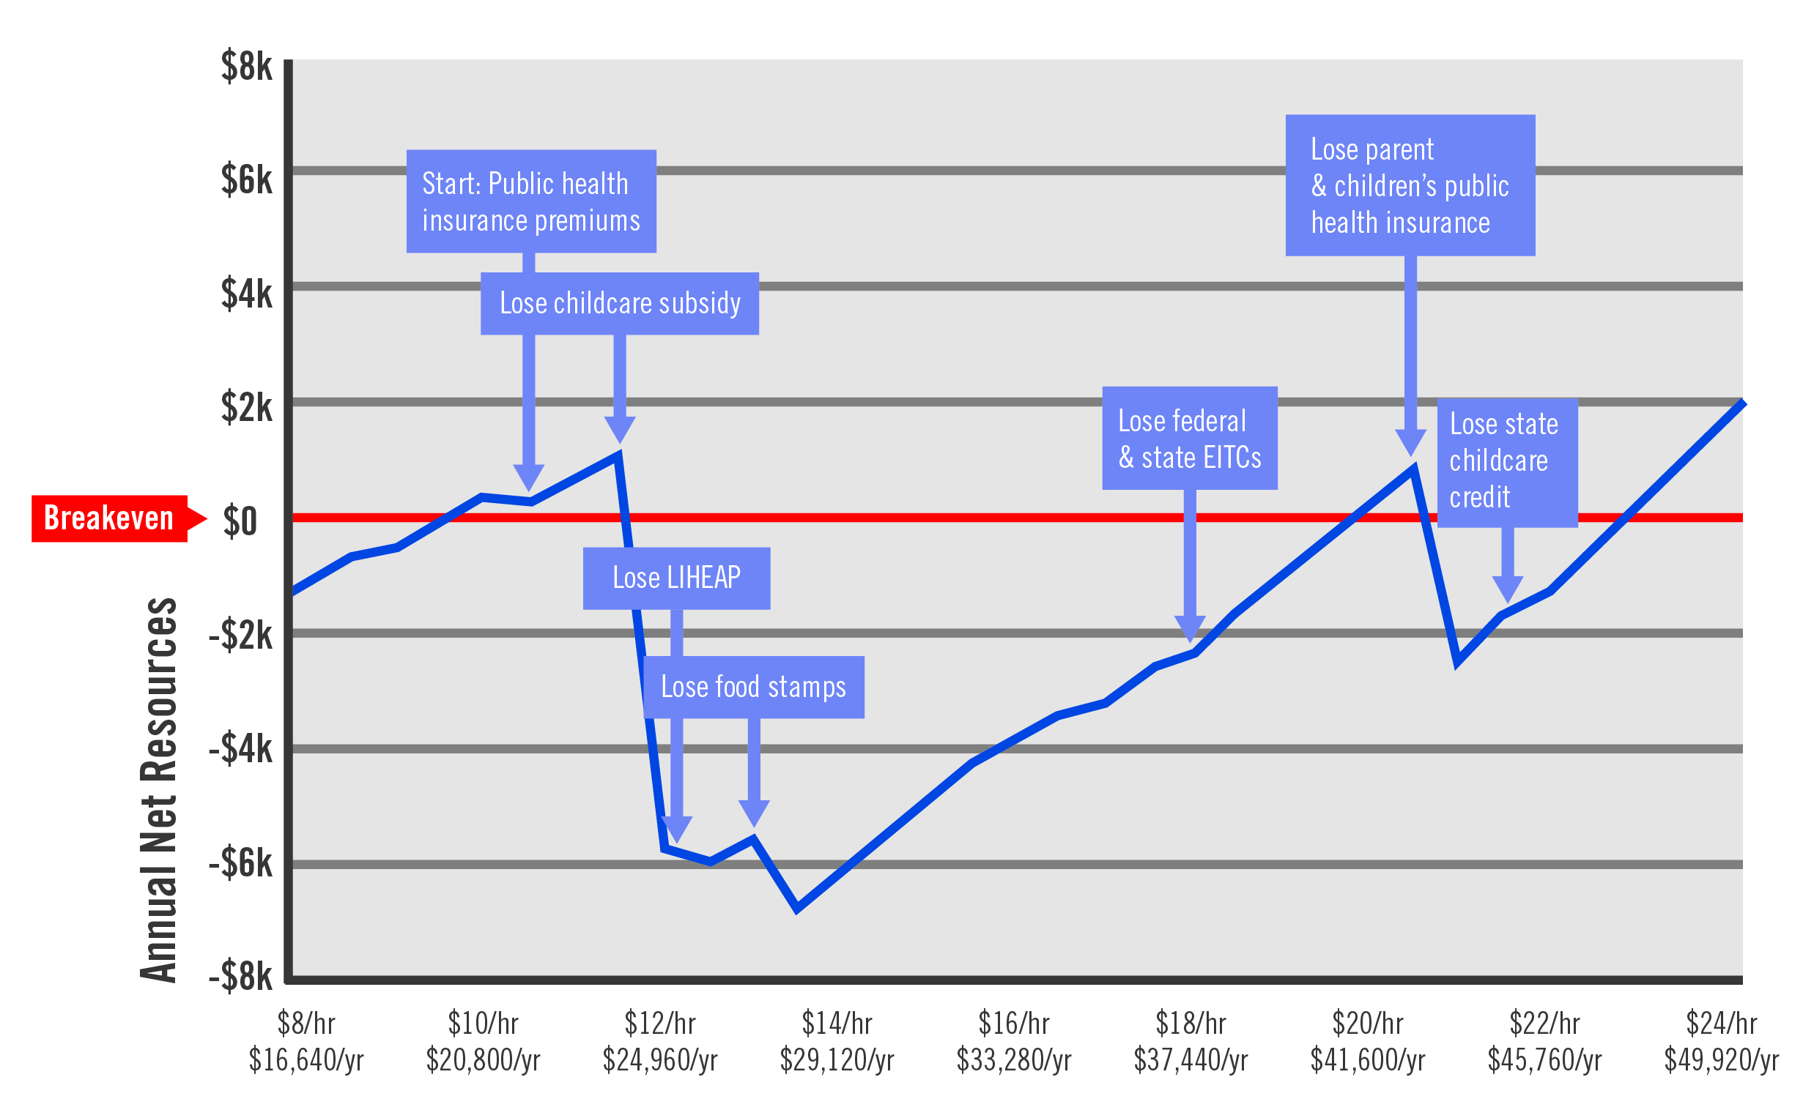
The result of the cliff is that low-income families become stuck: they still do not meet basic needs, but it is the best they can do unless they receive a significant wage increase. This is why filling gaps in needs is critical in helping to reduce the volatility created when families no longer qualify for critical benefits. Housing is one of those critical needs. If a family has stable and affordable housing low-income families have one less basic need to worry about their housing fits into their budget. On average, a household in Cedar Rapids spends 44% of their income on housing and transportation. If housing is affordable to a family, they are more able to focus on filling other needs to help them succeed and be more able to withstand sharp drop-offs from the benefits cliff.

Housing Cost Burden is a measure of housing affordability. When households are cost burdened, it means they are spending too much on housing. The federal standard for “too much” is 30% of the household’s monthly income.
Anthony, Jerry, and Bailey McClellan. "Trends in Housing Affordability in Iowa, 1990-2010." University of Iowa. Public Policy Center, Aug. 2015. Web. <http://ppc.uiowa.edu/housing/affordability/iowa>.
"H+T® Index." Welcome to The H+T Affordability Index. Center for Neighborhood Technology (CNT), n.d. Web. 19 Sept. 2016

