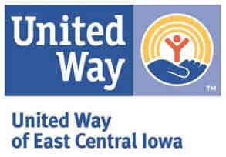

FY2017Mid-Year Reporting Checklist

Please use the following instructions for completing the FY2017 Mid-Year Reporting Requirements.

- Click on this web link to access the database:
  - http://uweci.upicsolutions.org/epledge/crm/Start.jsp

- Underneath the “Agency Reporting” tab at top of page click on “Outcome Reporting.”

- Please complete the following items for your FY2017 Mid-Year Reporting Requirements:
  - FY2017 Mid-Year Activity Outputs
  - FY2017 Mid-Year Indicator Measurements
  - FY2017 Mid-Year Demographics
  - FY2017 Mid-Year Narrative Questions
  - Impact Strategy Budget
  - Counter-terrorism Compliance Form
  - Board Member Roster
  - Submit all items

- Please contact your United Way Staff Representative if you have experienced significant changes to your strategies funding and/or services and need to make changes to your FY2017 Proposed activity outputs and indicator measurements.

Listed below are United Way Staff Representatives you may contact with any questions you have regarding the database and the Mid-Year reporting.

Education
FinancialStability

Health

Karen Lewis
319-398-5372ext.828
Karen.Lewis@uweci.org
AshleyZitzner
319-398-5372ext.825
Ashley.Zitzner@uweci.org
AnaClymer
319-398-5372ext.833
Ana.Clymer@uweci.org

