Volunteer Engagement

in Linn & Surrounding Counties
  - 2015Volnteer Engagement Needs Assessment Summary
Highlights
97% utilize volunteers to help deliver their social mission.
Volunteers play a significant role; 75% says volunteers are a large part of their main workforce.
Most organizations (72%) have capacity for more volunteers.
Word of mouth is the most common way volunteers get introduced to an organization.
Top 5 Needed Skilled Vols.
- Administrative/Clerical Community
- Organizing/Outreach
- Marketing & Comm. – Design & Writing
- Skilled Labor
Top 3 Trainings Requested
- Volunteer Recruitment
- Vol. Management for Staff
- Evaluating Vol. Service

Fundraising volunteers are the hardest to recruit & retain.
Over half (51%) do not use any volunteer referral website.
34% use United Way’s Volunteer Now.

Methodology & Overview
In December 2014 and January 2015 United Way of East Central Iowa (UWECI) conducted a survey of nonprofits and faith-based organizations in Linn & surrounding counties. The purpose of the survey is to better understand the challenges and opportunities organizations face in engaging and managing volunteers. A total of 96 individuals began the survey (64 completed it). Over half of the respondents represent Health/Human Service organizations, and the majority (87.5%) provide services in Linn County, with almost 50% of respondents solely providing services in Linn. 36% provide services to the broader UWECI service area (Linn, Benton, Cedar, Iowa, and Jones counties). Respondents fill a variety of roles in their organizations, although less than half (38%) are volunteer coordinators/managers. Just over half (51%) of the organizations who responded to the survey are small (0 - 10 paid employees) 15% have between 11 – 25 employees; 17% have more than 100.

Volunteerism in Our Community
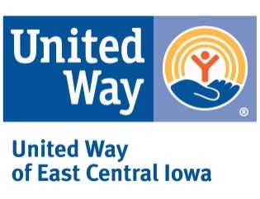
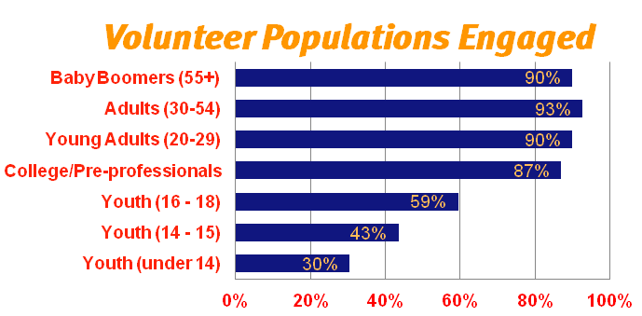
Agencies provide opportunities for an array of individuals and groups. Almost all have opportunities for those ages 20 years and older. There is a significant drop in the number of agencies that can engage youth volunteers. Though, nearly 60% reported that they have opportunities for families. 71% have opportunities to engage corporate volunteers, but only 53-57% reported they have opportunities for faith-based, service groups. Less than 30% currently are able to engage court-appointed community service.
Organizations vary in the number of individuals that volunteer for them annually. An impressive 30% responded that they engage more than 400 volunteers (note: this does not indicate the frequency). On the contrary, 21% engage 50 or fewer volunteers. There’s almost equal distribution for the remaining half of respondents.
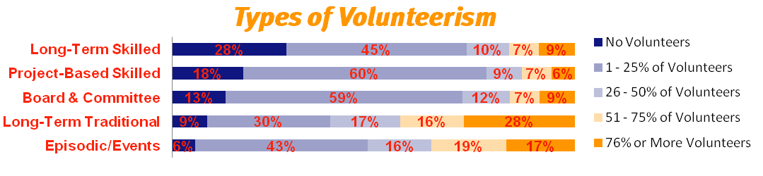
The assessment surveyed some generic types of volunteer engagement (long-term skilled, project-based skilled, board & committee, long-term traditional, and episodic) and the percentage of the organization’s volunteers that serve in that capacity. Almost 30% responded that they have 76% or more of their volunteers serving in long-term traditional roles; contrary to only 45% serving in long-term skilled roles. 28% reported that they do not use any volunteers in long-term skilled roles. Almost 60% of respondents reported that they use 1-25% for boards and committees.

Management Capacity
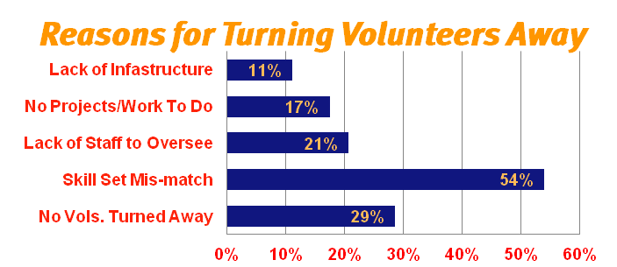
72% of organizations surveyed reported that they have the capacity to manage more volunteers; this is an increase of 10% since the 2011 survey. These organizations responded that they need anywhere between 2 and 100+ additional volunteers.
There was a decrease from 39% in 2011 to 29% who stated they have not turned away volunteers; may be due to agencies having more skilled volunteer opportunities. Over half cited that skill set mis-match was their main reason for not engaging volunteers.

Planning & Development
Organizations vary in the way that volunteer manager/coordinator’s role is involved in strategic planning and determining the volunteer needs of the organization. 36% of respondents (a decrease from 47% in 2011) stated that a volunteer manager/coordinator is included in all strategic planning efforts to help identify volunteer needs of the organization. 15% stated that the role is informed of the volunteer needs by staff & managers. 17% of respondents stated that the role is part of a committee that discusses volunteer needs; 13% stated that the role is solely responsible for assessing the volunteer needs of the organization. Over one quarter (28%) responded that their volunteer manager/coordinator regularly meets with Program/Initiative Managers to assess volunteer needs together.

Resource Allocation & Funding
Effective and efficient volunteer engagement can have great returns, yet as a community we don’t financially invest in volunteerism. More than half (54%) of respondents stated they do not have a budget dedicated for engaging volunteers. Of those who were willing to share what they budgeted for volunteer engagement, it varied from less than 1% to 3% of the organization’s budget; some just commented that it was very minimal or small. Only 44% have one or more paid full-time staff with the primary responsibility of coordination volunteers. Impressively though, 38% of total respondents said that they allocated money for training staff and/or volunteers.

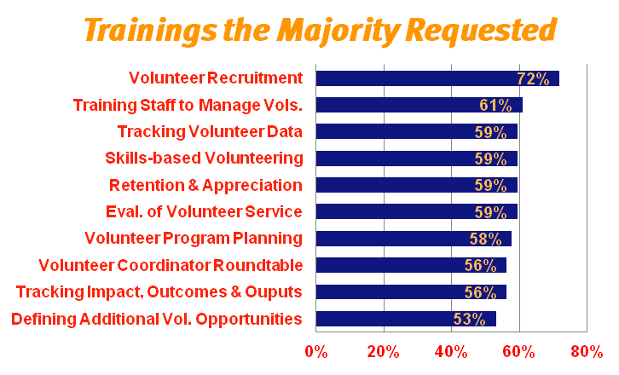
Effective Training
Many respondents indicated they are interested in receiving training. The most popular training topics include: Volunteer Recruitment, Training Staff to Manage Volunteers, and Tracking Volunteer Impact & Data. Collectively UWECI, Iowa Commission on Volunteer Service, Greater Cedar Ra pids Community Foundation and Leaders in Volunteerism will work together to address the needs of the organization in our community.

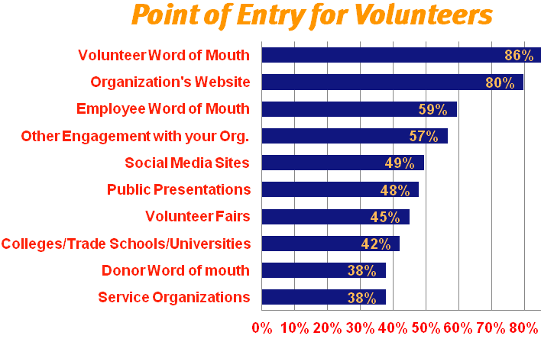
Onboarding & Supervision
Since volunteers are vital to most of the nonprofits that participated in the survey we took a deeper look at how they match the volunteer to the appropriate position(s), clarify the roles (between staff and volunteers), and orient and support volunteers during their service with the organization.

Recruitment
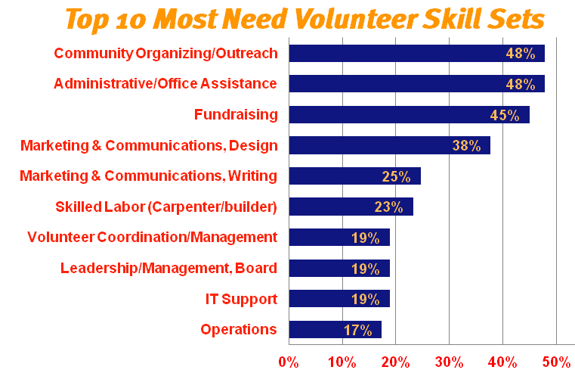
Although most organizations stated that they need more volunteers, UWECI’s survey indicates that organizations gain most of their volunteers through passive methods. The top recruitment methods were through word of mouth, organization’s website, previous engagement as a donor or event attendee, online, and outreach activities.
Over half (51%) do not use an online matching site. Of those who do use one, 65% utilize United Way’s Volunteer Now site. The other matching tool of significance was Volunteer Match.
The most commonly needed volunteer skill sets are Marketing & Communications, Fundraising, Community Organizing & Outreach, and Administrative/Clerical. Survey respondents indicated that the volunteers most needed by their organizations are also the hardest to recruit and often to retain.
Organizations are almost evenly split regarding skill-based recruiting efforts. 30% assess their skills gaps/needs before recruiting volunteers while 29% reported that they don’t. Proactively, 49% reported they actively seek volunteers who best fill the skill gaps/needs of their organization. One-third reported they fill positions with available volunteers. Of those, one-third does so with limited or no review of the volunteer’s resume and references. When it comes to engaging skilled volunteers only 20% feel that they have strong Executive Support for bringing on skills-based volunteers; whereas 10% reported that they have little or none.

Retention
Local organizations are doing well at retaining volunteers: Of the organizations that track retention 65% reported they retain over half of their volunteers after one year of service. Only 13% reported that they retain 25% or fewer of their volunteers.
The assessment also took a deeper look at organizational practices that may have an impact on agency’s ability to retain volunteers. The large degree, somewhat or not currently being practiced. Only 59% said that they either consistently or in large degree utilize a volunteer screening process. An alarming 65% answered that they only somewhat or don’t currently give staff training & recognition for working with volunteers.

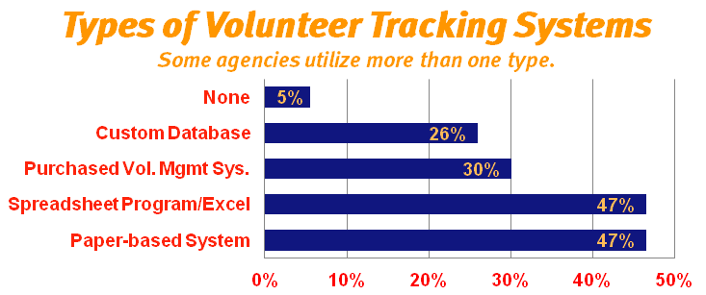
Tracking & Evaluation
The assessment substantiates that volunteer play a significant role in delivering the social mission of non-profits in our community. 10% of respondents don’t collect and track volunteer metrics. When it comes to tracking volunteers and their impact agencies use a variety of ways and often a combination of methods. By far the most common things that are tracked are Number of Volunteers (85%), Number of Hours (80%) and Frequency of Volunteering (59%). We also notice a significant decline to about 40% of respondents reported that they track the Hourly Value of the Volunteer Role, Outputs of the Work, and the Volunteer’s Company/Organization.

Evaluating Volunteer Performance & Satisfaction
The assessment had questions that covered self performance and satisfaction evaluations. Noticeably the numbers were very similar for the methods for both types of human capital, whether it was paid employees or volunteers. This is a significant increase from 2011’s assessment where 53% had one-on-one evaluations and 37% utilized surveys to evaluate the volunteer’s perception of their performance and satisfaction.
During the next assessment we may ask questions about the abilities and results in measuring their return on investment as a means to evaluate volunteer program effectiveness.

Current Challenges and Barriers
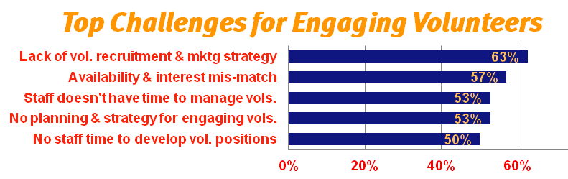
It was not surprising that respondents identified challenges within their organization and that the current state is keeping them from engaging volunteers or operating at their highest potential by utilizing volunteers. This is validated by research conducted by TCC Group, a national program and evaluation firm, that found less than 15% of organizations are effectively engaging & leveraging volunteers to meet the core mission of the organization.
One question asked “what the top five challenges the organization faces in it’s efforts to engage volunteers?” The most common response was Lack of a Volunteer Recruitment and Marketing Strategy (63%). Volunteer Availability and Interest Do Not Match Opportunities (57%) closely followed; that makes sense when you consider the most commonly selected challenge. Staff time was also acknowledged as one of the top five challenges for both managing volunteers and developing volunteer positions. Strategy came up a second time but focused more on the planning and strategy engaging volunteers in the work of the organization.
Another area that stood out as a barrier to agencies engaging volunteers was 65% responded that they only somewhat or did not currently provide staff with training and recognition for working with volunteers. When over half (66%) reported that there is not a staff member that has the primary responsibility for coordinating volunteers in addition to most volunteers’ day to day activities are managed by a variety of staff this seems to be a significant barrier to effectively and efficiently engaging volunteers.

Opportunities
Based on the responses to the 2015 Volunteer Engagement Needs Assessment there are a variety of areas that non-profits can work on to improve their ability, efficiency, and effectiveness in the way that they engage volunteers. Some notable areas of opportunity include:
Documenting the investment and return on volunteer investment for the organization. Will help organizations secure additional funding and allow the organization to justify allocating more resources. Due to our work with Service Enterprise we know that research shows $1 invested into effective and efficient volunteer engagement can yield a $3-6 return. 55% of agencies don’t have a budget for engaging volunteers even though 75% of organizations say volunteers are a large part or their main workforce. When 20% of respondents said they would benefit from engaging more volunteers, but don’t have the capacity, imagine what they could do for the community if they had enough resource to engage those volunteers.
At the end of the assessment there was the opportunity to write in the top three things that could vastly improve the volunteer program. Here are some of the more common answers.

- Database
- Funding, Budget, Resources
- Volunteer Coordinator
- Marketing, Outreach & Recruitment
- Training (for volunteers and staff)
- New volunteer role identification
- Leadership support
- Supervision & recognition plans
- Consistency across the organization
- Better volunteer position descriptions
- Volunteer availability matching needs
- More employee engagement with volunteers
- Better tracking of hours & impact
- Retention strategy
- More personalized volunteer communication

Local Agencies Invested the Time to Improve Volunteerism
We would like to thank all 96 agencies that participated in the 2015 Volunteer Engagement Needs Assessment. We appreciate the fact that these agencies took about fifteen or twenty minutes to provide information to help us gauge the current state of volunteerism and learn about where we can help support, empower and connect agencies to help them take volunteerism to the next level.
We would like to recognize the agencies that participated in the Assessment (note: not all agencies completed their contact information and some wished to remain completely anonymous).

ADA
Aging Services, Inc.
American Cancer Society
Benton County Volunteer Program
Big Brothers Big Sisters
Bridgehaven Pregnancy Support Center
Camp Courageous
Catherine McAuley Center
Catholic Worker House
Cedar Rapids Museum of Art
Cedar Rapids Public Library
Cedar Valley Humane Society
City of Cedar Rapids Solid Waste Division
Community Health Free Clinic
Families Helping Families of Iowa
Foundation 2
Gems of Hope
Girl Scouts of Eastern Iowa and Western Illinois
Girls on the Run of Eastern Iowa
Goodwill of the Heartland
HACAP
HD Youth Center
His Hands Free Medical Clinic
Horizons
Indian Creek Nature Center
Iowa Legal Aid
Jane Boyd Community House
Junior Achievement of Eastern Iowa
Kids First Law Center
Linn County Conservation
Marion Cares, Inc.
Matthew 25
MDA
Mercy Medical Center
Mission of Hope
Mount Mercy University
National Czech & Slovak Museum & Library
New Bohemia Group
NTS
PCI
Prairiewoods Franciscan Spirituality Center
Riders Club of Cedar Rapids
RVAP
SCORE
Southeast Linn Community Center
Takes
Tanager Place
Tanager Place
The Salvation Army
Volunteer Services of Cedar County
Wheelchair Ramp Accessibility Program
Young Parents Network

Volunteer Management Webinar Series
6 Parts January to April $125.00

- Understanding Volunteering: Exploring the Heart of the Volunteer Sector
- Planning: Building a Solid Foundation
- Recruiting & Placement: Matching Volunteer Skills with Service Needs
- Training & Orientation: Achieving Service Excellence
- Supervision: Maximizing the Volunteer Experience
- Evaluation: Improving Results Using Data & Feedback

United Way of East Central Iowa
Volunteer Engagement Team

Sue Driscoll – Manager of Volunteer Engagement
Sue.Driscoll@uweci.org 319.398.5372 x 822

Kayla Paulson – 55+ Initiative
Kayla.Paulson@uweci.org 319.398.5372 x 837

Emma Garvin – Jones Co. Volunteer Center
Emma.Garvin@uweci.org 319.560.0811

Please direct all Volunteer Needs Assessment
questions to Kayla Paulson.

