DATE
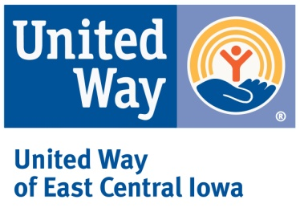
NAME
ADDRESS
CITY, STATE ZIP

Dear NAME:

United Way of East Central Iowa (UWECI) fights for the education, financial stability, and health of every person in our community. Will you join the fight?

Last year, your coworkers, neighbors, family members, and friends supported United Way and 38 community programs. Together with our nonprofit partners, we made a difference for more than 85,400 people in Benton, Cedar, Jones, and Linn Counties.

UWECI does more than fundraise. We are the hand raisers, fighting our community’s social crises and inspiring others to do the same. We are the game changers, working to assess needs and improve lives.

Because change doesn’t happen alone, we need your help. Your dollars address our community’s most critical problems:
Be part of the solution by visiting uweci.org/liveunited. Whether you volunteer, advocate, or give, you can make a difference.

Thank you for living United and supporting our community.

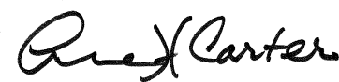
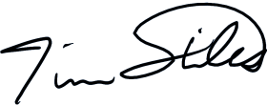
With gratitude,
Tim Stiles Anne Carter Kate Minette
President & CEO Campaign Co-chair Campaign Co-chair

P.S. Watch our 2017 campaign video at uweci.org/liveunited to learn more about UWECI.

