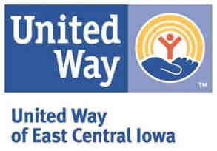
United Way CIPF FY18-19 Reporting Timeline

July 1, 2017: | Reporting Portal is Open for Year-end and Proposed data reporting
August 15, 2017 at 12pm: | Proposed Data is Due
September – October: | Solutions Teams review data, send questions to Partner Agencies
October- December: | Solutions Team and Agency roundtables by focus area
December 1, 2017: | Reporting Portal is open for Mid-year reporting
January 18, 2018 at 12 pm: | Mid-year and Proposed data reporting is due
February – March: | Solutions Team Reviews Mid-year data, send questions to Partner Agencies
July 1, 2018: | Online Reporting Portal is open for Year-end reporting. Zip Code spreadsheet for Agency Data entry is made available to Partner Agencies
August 15, 2018: | Year-End Data and Zip Code Spreadsheet is Due

