Make a difference for women in our community!
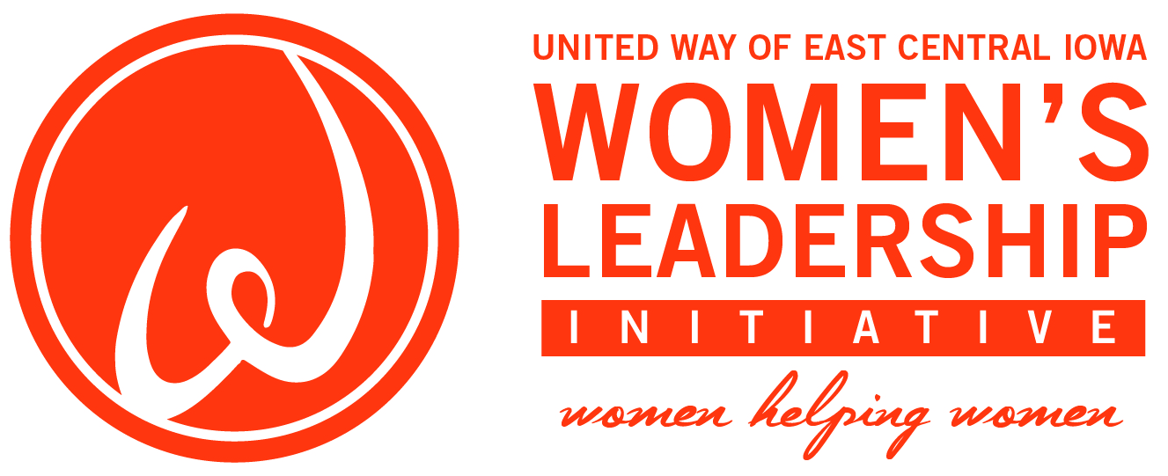
In 2006, United Way of East Central Iowa organized Women’s Leadership Initiative (WLI) to bring together a powerful leadership network of women. WLI members strengthen our community by investing in health care services for women in need.

On Thursday, August 3, WLI will host its annual Power of the Purse event at the home of Duane and Laura Smith. Join us for a fun evening that will include a silent purse auction, raffle for the grand prize purse, and information on how WLI improves lives in our community. All proceeds from this event will make positive changes in women’s health and increase awareness of available services.

Our success is only possible by the wide assortment of purses from our generous donors. Help WLI this year by donating one new purse, or making a cash donation that will go toward purchasing a purse or directly supporting the WLI fund.

Please fill out a contribution form for each purse donation. Mail or deliver your donation to United Way’s office by Thursday, July 20. Meeting this deadline will ensure we are able to recognize you for your thoughtful contribution at the event in August. Most of all, your donation will demonstrate to all in attendance your commitment to making a difference.

Thank you for being part of an event that supports not only WLI, but in turn, so many women right here in our community.

Sincerely,
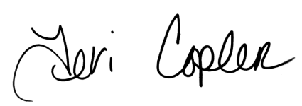

Teri Copler Julie Schneekloth
2016–17 WLI Chair 2017–18 WLI Chair

