SUBJECT LINE
We all win by living United

EMAIL BODY TEXT

Dear NAME:

United Way of East Central Iowa (UWECI) fights for the education, financial stability, and health of every person in our community. Will you join the fight?

Last year, your coworkers, neighbors, family members, and friends supported United Way and 38 community programs. Together, we made a difference for more than 85,400 people in Benton, Cedar, Jones, and Linn Counties. But UWECI does more than fundraise: we are the hand raisers and the game changers, working to assess needs and improve lives.

Your dollars help address our community’s most critical problems. Be part of the solution by visiting uweci.org/liveunited.

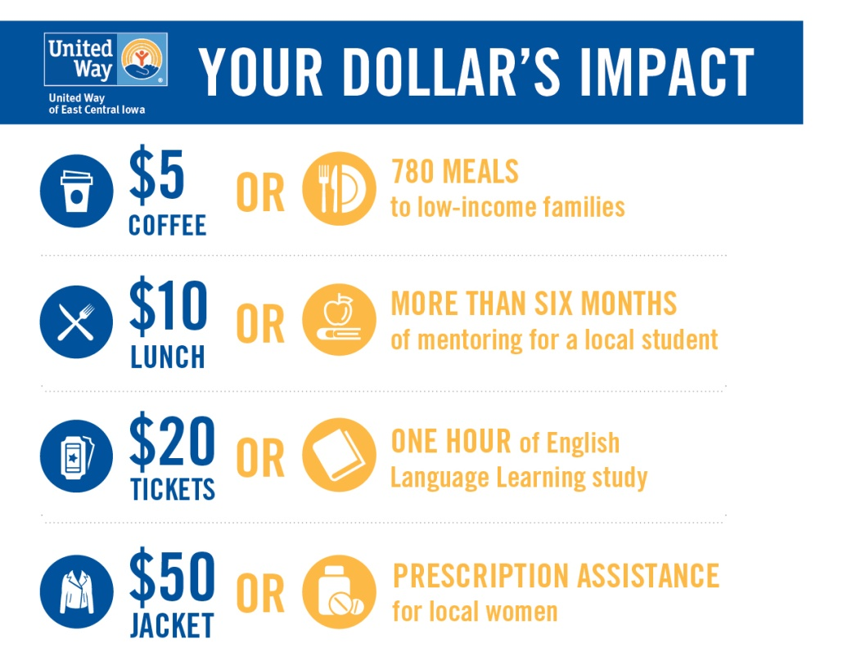

Thank you for living United and supporting our community.

With gratitude,

Tim Stiles
President & CEO
United Way of East Central Iowa

P.S. Watch our 2017 campaign video to learn more about UWECI.
SUBJECT LINE
Live United: Stand up for children left behind

EMAIL BODY TEXT

Dear NAME:

By age two, many low-income children are already behind other students in listening, counting, and other skills.

Starting behind their classmates can affect a student’s entire academic career. In fact, 44 out of 50 children who have difficulty learning to read in kindergarten will still have trouble in third grade.

Let’s give every child the chance to succeed. Stand up for the children left behind by visiting uweci.org/liveunited.

Thank you for living United and supporting our community.

With gratitude,

Tim Stiles
President & CEO
United Way of East Central Iowa

P.S. Learn more about our education programs by visiting uweci.org/education.

SUBJECT LINE
Live United: Battle to prevent homelessness

EMAIL BODY TEXT

Dear NAME:

In East Central Iowa, housing continues to be the number one need.

One in three renters and one in five homeowners are housing cost burdened, which means they spend more than 30% of their monthly income on housing. This limits their ability to afford other necessities like food.

Together with local nonprofits, we are addressing housing and homelessness issues. Help prevent homelessness and provide families with basic needs by visiting uweci.org/liveunited.

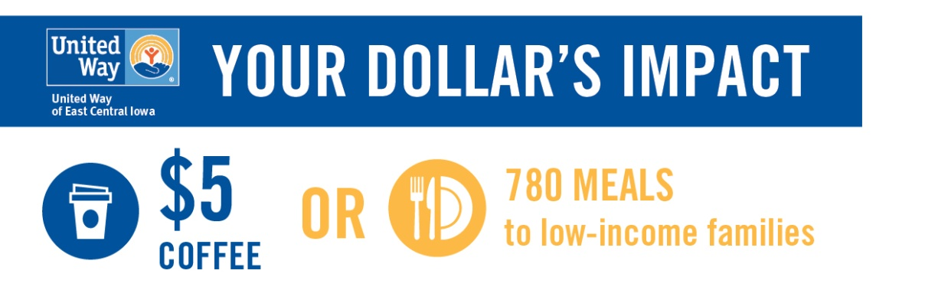

Thank you for living United and supporting our community.

With gratitude,

Tim Stiles
President & CEO
United Way of East Central Iowa

P.S. Learn more about how housing needs affect local families’ well-being at uweci.org/reports.

SUBJECT LINE
Live United: Confront poor mental health

EMAIL BODY TEXT

Dear NAME:

Depression is the leading cause of disability worldwide for both men and women; however, women and girls are twice as likely to experience it.

On top of that, low-income mothers are also twice as likely to experience some form of depression in their lifetime. Women continue to face many barriers to mental healthcare services.

As a response, our Women’s Leadership Initiative focuses on providing health services to local women in need. You can help confront mental health issues and support women’s overall health by visiting uweci.org/liveunited.

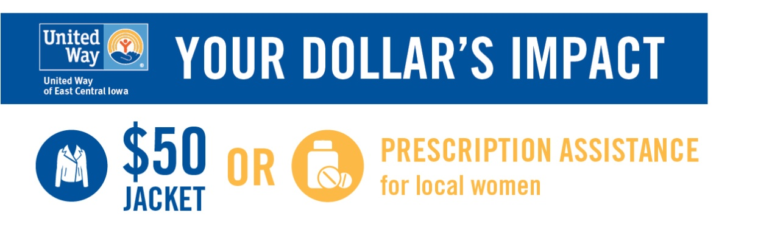

Thank you for living United and supporting our community.

With gratitude,

Tim Stiles
President & CEO
United Way of East Central Iowa

P.S. Learn more about women’s health needs by reading our Condition of Women report at uweci.org/reports.

