United Way of East Central Iowa
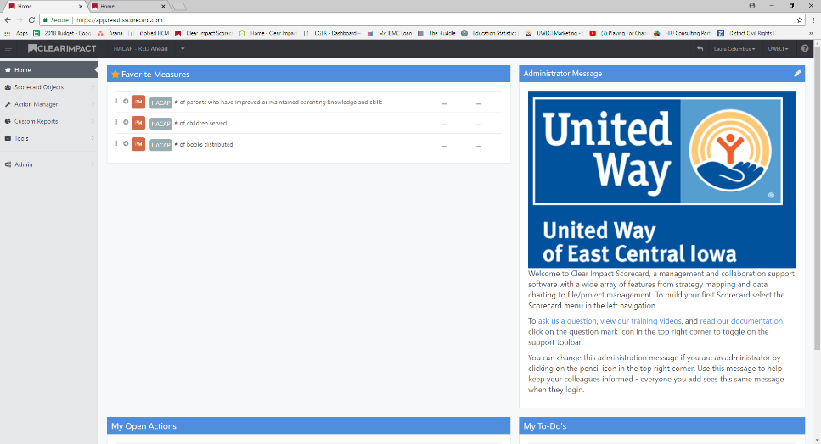
Clear Impact Reporting Instructions

- Go to Clear Impact to Login in: https://app.resultsscorecard.com/Account/Login?ReturnUrl=%2f

- Log in using your user name (email) and password (sent via email). This will take you to the home screen. Messages from United Way will be in the Administrator Message box. Figure 1
Figure 1
- Click on the drop down in the top left to select the program you are reporting on.

  - If your agency has multiple scorecards, you may need to click the plus to select a specific program. Figure 2
Figure 2

- You will click in each section to enter data.

- To enter your narratives, click on the Strategy Narrative text name. Figure 3
Figure 3
- Five sets of narrative questions will appear. Click on the edit (pencil) icon on the right side of the screen

- Click at the end of the text, enter down and enter your narrative. There are no character or word limits for the narratives. Click save and go to the next narrative box. Figure 4
Figure 4

- Once you have answered each narrative question and saved your work, click the back button the top right to return to the main scorecard. Figure 5
Figure 5
- Scroll down to the Community Output section and click on the first PM icon. Select Add Data Values. Figure 6
- Enter the most recent data for this Program Measure. Click save.***
  - When completing mid-year reporting, you will need to add two data lines for the next fiscal year’s proposed data. Click the plus button under Future and select the number of reporting fields you need to add.
  - Note: The Program Measure you are entering is listed at the top of the pop-up box.
  - Note: FY1 indicates the mid-year reporting line.
Figure 7
- Repeat for each Output Measure
  - If you have multiple outputs that equal a total Program Measure, you will find the Total Unduplicated to be a calculated measure. This is indicated by a green dot on the PM box.
  - For a short-cut, click on this PM and then select each PM that contributes to the calculation from this screen.
Figure 6
Figure 7

- Once you have entered all Outputs, scroll up to Community Outcomes

- Look for the first Outcome with “(Enter Data Here”) at the end and click on the PM to select Add Data Values. Figure 8

- Click on the first PM listed and enter the data for this PM. Also enter the measurement tool used for capturing this data in the Data Source field. Remember, the PM you are entering is shown at the top of the pop-up screen. Figure 9

- Click save and select the next PM.

- Once all PM’s are entered, the formulas will populate and show the results on the main data screen. Click Save.

- Continue selecting Outcomes with “(Enter Data Here)” until all measures are entered.

- The final step of reporting will be entering your client demographic information via Survey Monkey. Return to the Clear Impact Home Page and scroll down to “My Open Actions.

- Click on “Compete Demographic and Zip Code Data Survey. Figure 10

Figure 8
Figure 9
Figure 10

- Copy the survey link from the “Description” field on the right side of the screen to your internet browser to complete the survey for EACH PROGRAM.

**YEAR END: Year end data should be a cumulative number for the year, total from July 1 – June 30.

For Assistance with Clear Impact, contact:
Laura Columbus
Laura.columbus@uweci.org
319-398-5372 Ext. 846
Or
Ana Clymer
Ana.Clymer@uweci.org
319-398-5372 ext. 833

**Note, Laura will be out of the office July 23 -- 27 with limited access to email and August 2 –3 with no access to email.
Ana will be out of the office/unavailable July 30 – August 10.

