DATE

NAME
ADDRESS
CITY, STATE ZIP

Dear NAME:

United Way of East Central Iowa (UWECI) fights for the education, financial stability, and health of every person in our community. Will you join the fight?

Last year, your coworkers, neighbors, family members, and friends supported crucial community programs with their donation to UWECI. Together, we made a difference to nearly 80,000 people in Benton, Cedar, Iowa, Jones, and Linn Counties.

UWECI does more than fundraise. We are the hand raisers, fighting our community’s social crises and inspiring others to do the same. We are the game changers, working to assess needs and improve lives.

Since change doesn’t happen alone, we need your help. Your dollars address our community’s most critical problems:

You can fight for all East Central Iowans and make a difference by volunteering, advocating, or giving. Learn more about UWECI by watching our video at uweci.org/solutions.

Thank you for living United and supporting our community.

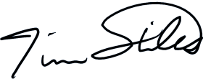
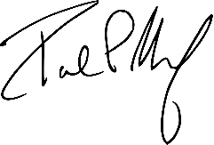
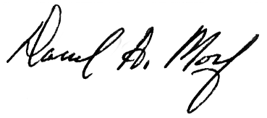
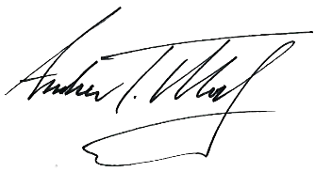
With gratitude,
Andrew Morf Darrel Morf Paul Morf Tim Stiles
Campaign Co-Chair Campaign Co-Chair Campaign Co-Chair President & CEO

