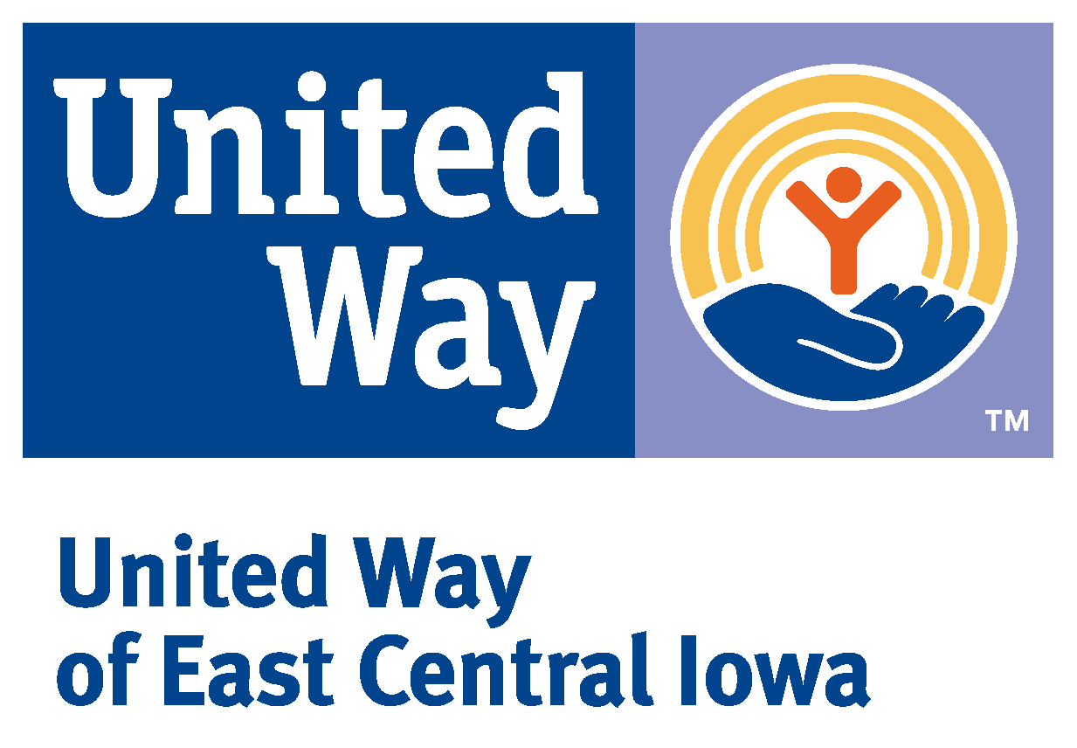
UWECI Agency Budget Form Instructions
Please use these instructions when completing the UWECI Agency Budget Form. The budget is not complete unless all Schedules are completed. These instructions are based on instructions for the 2016 IRS Form 990. Additional clarification may be found in the IRS instructions for Form 990 at:
https://www.irs.gov/pub/irs-pdf/i990.pdf
Revenue
These line items should tie to the lines in the Form 990 Part VIII Statement of Revenue. The equivalent lines on the Form 990 are in parentheses after the UWECI Budget Form line number.
Line 1 UWECI Partner Funding – this line reflects all multi-year Partner Fund grants – actual or projected if this budget accompanies a funding proposal.
Line 2 Other UWECI Funding – this line reflects donor designation, any time-limited grant dollars or other non-Partner grant dollars.
Line 3 Funding from other United Ways – this line reflects all funding received from other United Ways – e.g. Cedar Valley United Way, United Way of the Quad Cities, Community Health Charities, Combined Federal Campaign, etc.
Note: UWECI Agency Budget lines 1-3 should tie to Form 990 Statement of Revenue Line 1a.
Line 4 Membership Dues (1b)
Line 5 Contributions and Events (1 c and f) – Gross amounts received through fundraisers and contributions from the general public.
Line 6 Foundation Grants – Revenue from private, corporate or community foundations separate from other revenue in 1f.
Line 7 Government Grants (1e) – These may be Federal, State or Local governmental grants. Line item detail should be provided on Schedule A.
Line 8 Program Service Revenue (2g) – Program service revenue may include revenue for providing a service, facility, or product; tuition, event fees, etc.
Line 9 Investment Income (3) – Interest from savings and temporary cash investments, dividend and interest income from equity and debt securities, etc.
Line 10 Other Revenue – This may include sales of assets other than inventory, rent, royalties, sales of inventory, etc. Please complete Other Revenue Schedule B. Noncash contributions should be recorded on the Noncash Contributions Schedule D.
Line 11 Total Agency Revenue (Part I, Line 12 and Part VIII, line 12) Total Revenue should equal gross receipts from all sources and should match 990 Part 1, line 12. If it does not, please explain the variance.
Expenses
These line items should tie to the lines in the Form 990 Part IX Statement of Functional Expenses (Column A)
Line 12 Salaries (Line 5 & 7) - Employee salaries, wages, fees, bonuses, severance payments, etc.
Line 13 Benefits and Payroll Taxes (Line 8, 9 & 10) This line includes pension plan contributions, insurance, health and welfare programs and payroll taxes.
Line 14 Fees for services (non-employees) (Line 11 a-g total) Fees for services by independent contractors that may include management, legal, fundraising or investment consulting.
Line 15 Advertising and Promotions (Line 12)
Line 16 Office Expenses (Line 13) – This line includes supplies, postage, telephone, shipping, bank fees and similar costs.
Line 17 Information Technology (Line 14) This line should include all expenses related to information technology i.e. software, hardware, support services, web design as well as security services.
Line 18 Occupancy/Utilities (Line 16)
Line 19 Travel/Meetings/Conferences (Line 17, 18, & 19)
Line 20 Interest (Line 20)
Line 21 Assistance to Individual Households/Grants (Line 2)
Line 22 Dues (Reported as part of Line 21)
Line 23 Depreciation (Line 22)
Line 24 Insurance (Line 23) This line should not be used to report employee related insurance costs.
Line 25 Other Expenses – This line may include Form 990 Part IX lines 15, 21, 24 a-f, and any other expense category not described above.
Line 26 Total Agency Expense (Part I, Line 18 and Part IX, line 25). This line should match 990 part 1, line 18. If it does not make please explain the variance.
Line 27 Revenue Less Expenses (Line 11-Line 27) Agency will provide an explanation, including a resolution, when expenses exceed revenue.
Attach a narrative explanation for any revenue or expense line item variance between budget years greater than 10% and $10,000.
United Way of East Central Iowa reserves the right to request additional information.

