United Way of East Central Iowa
Clear Impact Reporting Instructions

- Go to Clear Impact and log in using your user name (email) and password. https://app.resultsscorecard.com/Account/Login?ReturnUrl=%2f

- This will take you to the home screen. Messages from United Way will be in the Administrator Message box.

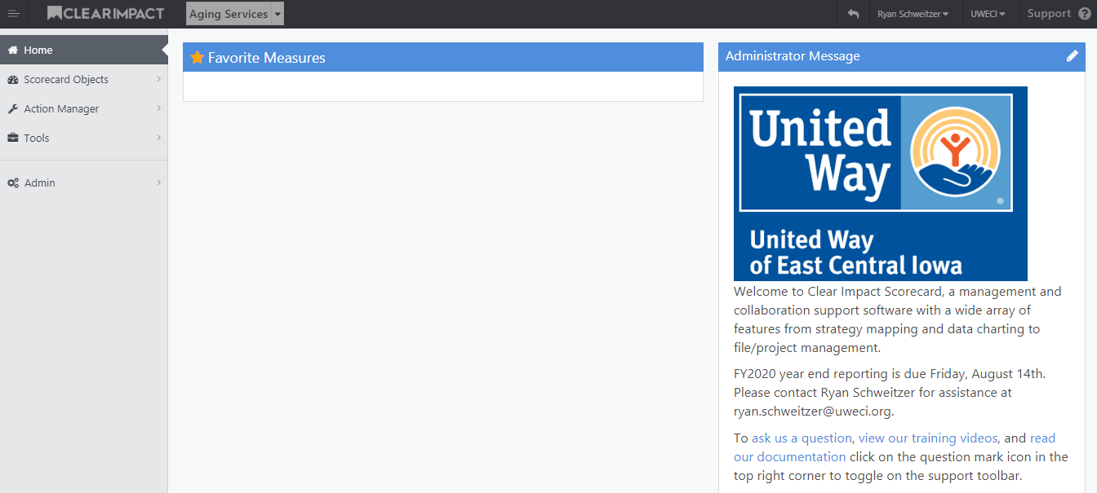

- Click on the top drop down box to select your agency.

- Click on a performance measure to enter data.

- Click on the “Edit Data” button.

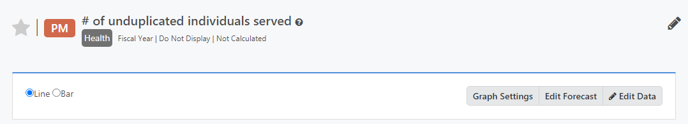

- Enter the data point that is expected to occur under “Target Value” in FY1 for mid-year and FY2 for year-end reporting. Enter the data point that actually occurred under “Actual Value” in FY1 for mid-year and FY2 for year-end reporting. Then click the “Save” button.

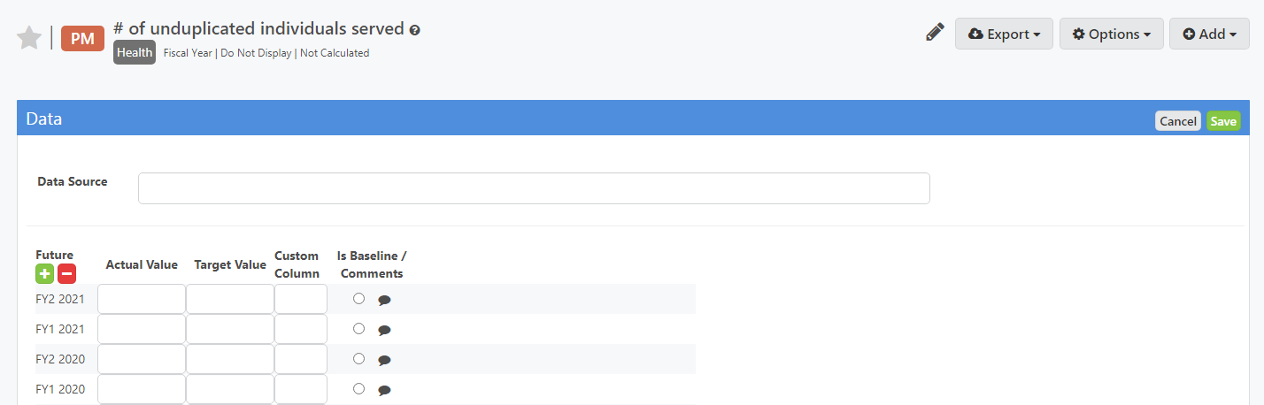

- Click on your agency name to get back to the scorecard.

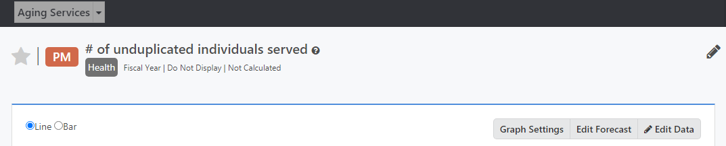

- Repeat steps 4-7 for each performance measure.

- Click on the program name to enter narrative.

- Click on the pencil icon in the “Program Narrative” bar.

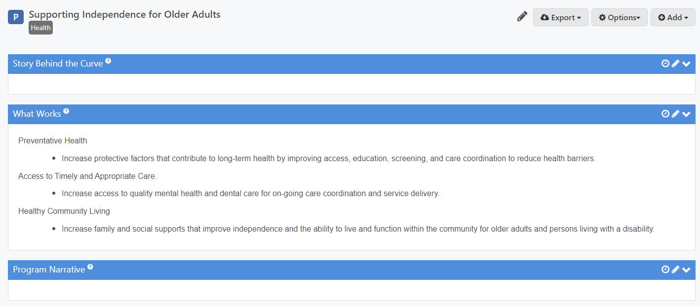

- Write narrative in the free response box and click the “Save” button.

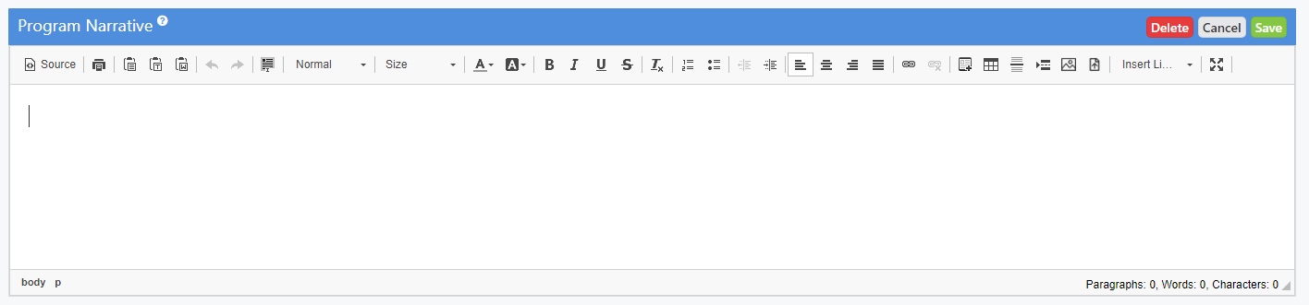

- Click on your agency name to get back to the scorecard.

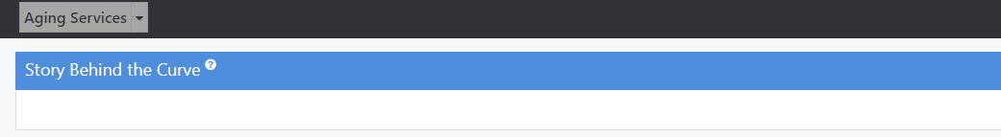

- Repeat steps 9-12 for each program.

NOTES:
Mid-year reporting should include data and narratives from July 1 – Dec 31.
Year-end reporting should include data and narratives from July 1 – June 30.

For assistance, contact Ryan Schweitzer: ryan.schweitzer@uweci.org

